Assignment 1 Task 2
NourishShare
Susmita Shrestha – E2300584
Ghan Shyam Shrestha – E2300557
Rupesh Thapa –E2300570
Table of Contents
CHAPTER 1 Requirement Specification Document 1
1.1 Functional Requirements 1
1.2 Non Functional Requirements 2
CHAPTER 2 Modelling the Requirements 4
2.1 Ghan Shyam Shrestha – E2300557 4
2.1.1 Epic 1 – Register User and Privacy Settings 4
2.1.2 Epic 2: Food Analytics 5
2.2 Susmita Shrestha – E2300584 7
2.2.1 Epic 1: Manage Food Inventory 7
2.2.2 Epic 2: View Notifications 9
2.3 Rupesh Thapa – E2300570 11
2.3.1 Epic 1: Browse Food Items 11
2.3.2 Epic 2: Plan Weekly Meals 12
CHAPTER 3 Architectural Diagram 14
CHAPTER 4 High Level Design Components 16
4.1 Domain class Diagram 17
4.2 Entity Relationship Diagram 18
4.3 Site Map 19
CHAPTER 5 Wireframes and High Fidelity Images 20
5.1 Wireframes of NourishShare 20
5.1.1 Landing/ Home Page 20
5.1.2 Register Users Page 21
5.1.3 2FA Page 21
5.1.4 Account Privacy Page 22
5.1.5 Login Page 22
5.1.6 Food Inventory Page 23
5.1.7 Food Item Details 24
5.1.8 Add Item 24
5.1.9 Delete Food Item Dialog Box 25
5.1.10 Dashboard Page 26
5.1.11 Weekly Meal Plan 26
5.1.12 View Notifications Page 27
5.2 High Fidelity Designs 28
5.2.1 Landing Page 28
5.2.2 Register Page 29
5.2.3 View Notifications Page 29
5.2.4 Weekly Meal Plan Page 30
5.2.5 Food Inventory Page 30
5.2.6 Account and Privacy Settings Page 31
CHAPTER 6 System Design 32
6.1 Database Design 33
6.1.1 Collection: Users 33
6.1.2 Collection: Food 34
6.1.3 Collection: Category 34
6.1.4 Collection: Donation 35
6.1.5 Collection: MealPlan 36
6.1.6 Collection: Notification 37
CHAPTER 7 Future Recommendations 38
Conclusion 39
References 40
Appendix 41
Appendix A – Deployment Diagram 41
Appendix B – Site Map 41
Appendix C – Entity Relationship Diagram 41
Appendix D – Figma Link 41

List of Figures
Figure 1: Deployment Diagram of NourishShare Web Application 14
Figure 2: Domain Class Diagram of NourishShare Web Application 17
Figure 3: Entity Relationship Diagram of NourishShare Web Application 18
Figure 4: Site Map/ Hierarchy Diagram of Nourish Share Web Application 19
Figure 5: Landing Page Wireframe 20
Figure 6: Register Page Wireframe 21
Figure 7: 2FA Wireframe 21
Figure 8: Account and Privacy Setting Wireframe 22
Figure 9: Login Page Wireframe 22
Figure 10: Inventory Management Wireframe 23
Figure 11: Food Item Details Wireframe 24
Figure 12: Add Food Items Wireframe 24
Figure 13: Delete Food Item Dialog Box Wireframe 25
Figure 14: Dashboard Wireframe 26
Figure 15: Weekly Meal Plan Wireframe 26
Figure 16: View Notifications Wireframe 27
Figure 17: Landing Page Design 28
Figure 18: Register Page Design 29
Figure 19: Notifications Page Design 29
Figure 20: Weekly Meal Plan Design 30
Figure 21: Food Inventory Page Design 30
Figure 22: Account and Privacy Settings Design 31

List of Tables
Table 1: Functional Requirements Table 2
Table 2: Non Functional Requirements Table 3
Table 3: Ghan Shyam – Regiser User and Privacy Setting - Epic 1 Table 5
Table 4: Ghan Shyam - Food Analytics - Epic 2 6
Table 5: Susmita - Manage Food Inventory - Epic 1 8
Table 6: Susmita - View Notifications - Epic 2 10
Table 7: Rupesh - Browse Food Items - Epic 1 12
Table 8: Rupesh - Plan Weekly Meals - Epic 2 13
Table 9: Architectural Description Table 15
Table 10: High Level Design Components Table 16
Table 11: User collection table 33
Table 12: Food Collection Table 34
Table 13: Category Collection Table 34
Table 14: Donation Collection Table 35
Table 15: MealPlan Collection Table 36
Table 16: Notification Collection Table 37

Requirement Specification Document

Functional Requirements
These are those requirements that are expected from a system to perform. They are the functions or the features of the systems like add to cart, clicking on a button does something, in an attendance management system being able to record the attendance of students. The functional requirements of the NourishShare web application are written below:
ID | Requirement | Priority | Category
FR-1 | The system should allow users to register a new account in the system using their phone number of National Identification Number (In Future Versions). | Must | Registration
FR-2 | The system should allow the users to enable or disable the two factor authentication while registration process or after registering successfully. | Must | Security
FR-3 | The system should send a verification link to the entered email address for confirming the registration success. | Could | Registration
FR-4 | The system should allow users to add new food items in their inventory. It should contain name, quantity, category, expiry date, and storage location. | Must | Inventory
FR-5 | The system should allow users to view their food listings that are available in their inventory along with their entered details. | Must | Inventory
FR-6 | The system should allow users to edit their food listings or delete the food item from their listing. | Must | Inventory
FR-7 | The system should allow users to donate food after fulfilling certain criteria and create a food listing that is visible to other users. | Must | Donation
FR-8 | The system should allow users to browse and filter donations listings. The filter should be either by category, location, or donation type. | Must | Donation
FR-9 | The system should provide users with their personalized dashboard which contains the analytics of their progress and their activity. | Should | Analytics
FR-10 | The system should send notifications to users for food items which expiry dates are coming. | Must | Notifications
FR-11 | The system should also send notifications for donation listings, meal plans and donation confirmation. | Must | Notifications
FR-12 | The system should allow users to create, update and delete their weekly meal plans that they linked to their inventory items. | Must | Meal Planning
Table 1: Functional Requirements Table

Non Functional Requirements
These are those requirements or qualities that a normal user expects form the system like performance, scalability, security, usability, maintainability, responsiveness and others. The nonfunctional requirements of the NourishShare web applications are as follow:
ID | Category | Requirement | Priority
NF-1 | Performance | The system should load the inventory items within few seconds like up to 3 seconds under normal network connections. | Should
NF-2 | Security | The passwords of the users should not be stored in a plain text in the database. The passwords of the users should be hashed using algorithms like using bcrypt js. | Must
NF-3 | Security | The transmission of data between client and server should be encrypted using HTTPS/TLs. | Should
NF-4 | Usability | The user interface of the web application should be simple and easy to understand and use. Even the users who are first timers should be able to easily navigate and understand how the application works. | Must
NF-5 | Scalability | The database design should be designed in such a way that even a huge numbers of users can be accommodated and the performance of the web application should not decrease. | Could
NF-6 | Compatibility | The web application should properly work in different web browsers like Google Chrome, Firefox, Brave, Edge and other. | Should
NF-7 | Responsiveness | The application should be responsive in all devices. It should be useable in smartphones, tablets or bigger screen while maintaining the features and performance. | Must
Table 2: Non Functional Requirements Table

Modelling the Requirements
The requirements that the each group members should follow for their respective use cases are shown below in the table that is provided in the Appendix of the question. Each group members are assigned two use case.

Ghan Shyam Shrestha – E2300557

Epic 1 – Register User and Privacy Settings
User Story 1 | As a new user,  I need to register myself in NourishShare using my phone number,  So that I can login and use NourishShare application.
Acceptance Criteria | Given a valid phone number and email address,  When the user submits the form,  Then an account it created.
MoSCoW | Must
Tasks | Designing the Registration form UI.  Building the registration API.  Validating the phone number using regular expression.
Test Cases | -
User Story 2 | As a registered user,  I need to set up Two Factor Authentication,  So that I can make my account more secure.
Acceptance Criteria | Given a registered account in the NourshiShare application,  When the user enables 2FA and enters a valid OTP code,  Then 2FA is activate for future logins.
MoSCoW | Must
Tasks | Building 2FA setup UI.  Storing the status of 2FA in the user profile.  Enforcing 2FA on future logins.  Integrating OTP generating libraries for validation.
Test Cases | -
User Story 3 | As a user,  I need to configure my privacy settings,  So that I can control who can view my profile.
Acceptance Criteria | Given a logged in user,  When the user changes a privacy setting,  Then the new setting is applied immediately.
MoSCoW | Should
Tasks | Designing the privacy settings UI.  Building the settings update API.
Test Cases | -
Table 3: Ghan Shyam – Regiser User and Privacy Setting - Epic 1 Table

Epic 2: Food Analytics
User Story 1 | As a user,  I need to view my personal dashboard that shows my food saved, donations and wastage,  So that I can understand my food consumption habits.
Acceptance Criteria | Given a recorded inventory and donation history,  When the user opens the analytics dashboard,  Then a chart is displayed showing the food saved, donation made and wastage done.
MoSCoW | Must
Tasks | Designing the Analytics Dashboard UI.  Integrating external library for chart generation (chart.js).
Test Cases | -
User Story 2 | As a user,  I need to compare my food wastage over different time periods,  So that I can track my progress.
Acceptance Criteria | Given the required data and activity,  When the user selects a time range,  Then the chart is updates to show the comparison during that period.
MoSCoW | Should
Tasks | Building time range filter component.  Updating the chart dynamically.
Test Cases | -
User Story 3 | As a user,  I need to export my analytics report as a simple report,  So that I can keep a personal record of the activities and my progress.
Acceptance Criteria | Given analytics data is shown,  When the user clicks “export” button,  Then a PDF or CSV file is generated and downloaded.
MoSCoW | Could
Tasks | Building the export button.  Generating PDF/CSV using external library.
Test Cases | -
Table 4: Ghan Shyam - Food Analytics - Epic 2

Susmita Shrestha – E2300584

Epic 1: Manage Food Inventory
User Story 1 | As a new user,  I need to add a food item to my inventory,  So that I can know what food items I have and which ones I need.
Acceptance Criteria | Given a valid food item details,  When the user submits add item form,  Then the item appears in the inventory list.
MoSCoW | Must
Tasks | Designing the add item form UI.  Building the create item API.  Validating the input fields.  Storing the item detail in the database.
Test Cases | -
User Story 2 | As a user,  I need to view all the food items in my inventory,  So that I can know what food items I have in my home.
Acceptance Criteria | Given the items is available in the inventory,  When the user opens the inventory page,  Then all the items are displayed with their entered details.
MoSCoW | Must
Tasks | Designing inventory List UI.  Building the get items API endpoint.  Implementing pagination and sorting.
Test Cases | -
User Story 3 | As a user,  I need to update an existing food item,  So that I can edit the food items details where I made mistakes.
Acceptance Criteria | Given an existing food item,  When the user edits and saves item,  Then the updated details are reflected in the inventory list.
MoSCoW | Must
Tasks | Designing the edit item UI.  Building the item update API.
Test Cases | -
User Story 4 | As a user,  I need to delete a food item,  So that I can keep my inventory with accurate food items and their details.
Acceptance Criteria | Given an existing food item in the inventory,  When the user confirms deletion,  Then the item is removed from the inventory list.
MoSCoW | Must
Tasks | Building the delete item API endpoint.  Adding the confirmation dialog UI.  Removing item from the item list and the database.
Test Cases | -
Table 5: Susmita - Manage Food Inventory - Epic 1

Epic 2: View Notifications
User Story 1 | As a user,  I need to receive a notification when a food item is about to expire,  So that I can make necessary actions as per the notification.
Acceptance Criteria | Given an item is within 3 days of expiry,  When the schedule time arrives,  Then a notification is created and send to the user.
MoSCoW | Must
Tasks | Building the notification sending controller logic.  Choosing the notification UI icon.  Storing notifications in the database.
Test Cases | -
User Story 2 | As a user,  I need to receive a notification when a new donation listing is posted,  So that I can claim the donation.
Acceptance Criteria | Given a new donation listing,  When it matches a users’s saved filter or preferences,  Then a notification is send to the user.
MoSCoW | Should
Tasks | Building donation matching logic and writing controller code.  Designing notification content.
Test Cases | -
User Story 3 | As a user,  I need to view all my past notifications,  So that I can review what I have missed out on.
Acceptance Criteria | Given a notification exists for a user,  When the user opens the notification center,  Then all notifications are listed.
MoSCoW | Could
Tasks | Designing the notification center UI.  Building the get notifications API  Implementing the read/unread status.
Test Cases | -
Table 6: Susmita - View Notifications - Epic 2

Rupesh Thapa – E2300570

Epic 1: Browse Food Items
User Story 1 | As a food donor,  I need to create a donation listing for my excess food,  So that I can help other users find and claim it.
Acceptance Criteria | Given a valid donation details,  When the user submits the listing form,  Then the listing appears in the public browsing page.
MoSCoW | Must
Tasks | Designing the donation listing form UI.  Building the donation API.  Storing the donations listings in the database.
Test Cases | -
User Story 2 | As a donation recipient,  I need to brose available donation listings,  So that I can find food items that I need.
Acceptance Criteria | Given donation item listing exists,  When the user opens the browse page,  Then all available listings are shown.
MoSCoW | Must
Tasks | Building the get API for donation listing.  Implementing the listing card components.  Designing the browse listing UI.
Test Cases | -
User Story 3 | As a donation recipient,  I need to filter donation listings by category or donation type,  So that I can quickly find relevant items.
Acceptance Criteria | Given multiple donation listings exists,  When the user applies a category filter,  Then only the matching listings are shown.
MoSCoW | Should
Tasks | Building the filter UI component.  Showing the filtered listings items dynamically.
Test Cases | -
User Story 4 | As a donation recipient,  I need to claim the donation listing,  So that I can let the donor know that the item has been requested.
Acceptance Criteria | Given an active donation listing.  When the recipient clicks “Claim”,  Then the listing status changes to “claimed” and the donor is notified.
MoSCoW | Could
Tasks | Updating the donation listing status.  Sending notification to the donor after the request.
Test Cases | -
Table 7: Rupesh - Browse Food Items - Epic 1

Epic 2: Plan Weekly Meals
User Story 1 | As a user,  I need to create a weekly meal plan,  So that I can plan and organize my meals in advance.
Acceptance Criteria | Given the user is logged in,  When the user creates a meal plan with days and meals,  Then the plan is saved and displayed on the meal planning page.
MoSCoW | Must
Tasks | Designing the meal plan creation UI.  Building the meal plan API.  Designing the Weekly Calendar Layout.
Test Cases | -
User Story 2 | As a user,  I need to link my planned meals to my food items in the inventory,  So that I can plan meals for what I have.
Acceptance Criteria | Given the inventory item exists,  When the user selects an item while creating a meal,  Then the meal is linked to the inventory item.
MoSCoW | Must
Tasks | Building the inventory picker component.  Linking the meal entries to the food item of the inventory.  Making the API for meal plan.
Test Cases | -
User Story 3 | As a user,  I need to edit or delete a planned meal,  So that I can adjust my plans as per my need.
Acceptance Criteria | Given an existing meal plan entry,  When the user edits or deletes it,  Then the meal plan changes should be shown immediately.
MoSCoW | Should
Tasks | Building add and delete UI component.  Making the API for edit and delete meal plan.
Test Cases | -
User Story 4 | As a user,  I need to receive a reminder before a planned meal,  So that I can be alerted about the plan and can prepare it.
Acceptance Criteria | Given a meal plan with a reminder enabled.  When the scheduled reminder time arrives,  Then a notification is sent to the user.
MoSCoW | Could
Tasks | Building the reminder scheduling logic.  Integrating with notification system.
Test Cases | -
Table 8: Rupesh - Plan Weekly Meals - Epic 2

Architectural Diagram
Our web application NourishShare follows a three tier client-server architecture. The deployment diagram models the relationships between software and hardware components and how they are connected physically (IBM, 2023). The architectural or deployment diagram is shown below:
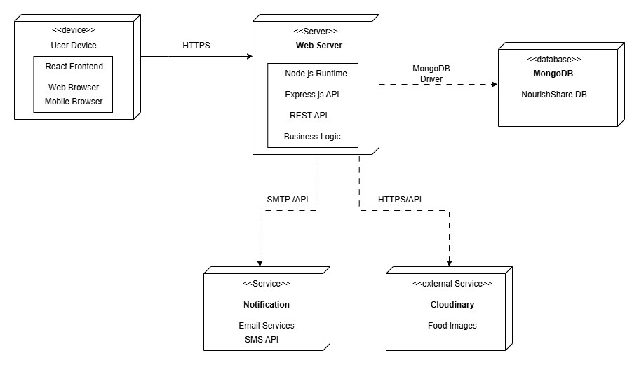
Figure 1: Deployment Diagram of NourishShare Web Application
The technologies used in each layer:
Layer | Technology | Responsibility
Client | React JS( SPA) | - To make the development process efficient by making components helps to reduce the repetitive code.  - To make single page application for faster page loading.
Application | Node JS + Express JS | - To make the API endpoints for the web application.  - To handle the authentication and authorization of users using JWT.
Data | MongoDB | - To store the data of the users, the food details, notifications, donation listings, notifications and the meal plans.
Table 9: Architectural Description Table
The deployment diagram represents our web application using a three tier architecture. The presentation tier is made using React JS. It runs on the client’s browser and handles the user interfaces. It allows for fast and dynamic rendering without the need for full page reloads (Guduru, 2025). Node JS and Express JS are used to create the API, handle user authentication, and communicate between the client and the database in the application tier. MongoDB is used in the data tier which stores the identified entities in JSON-like format. They all work smoothly together as JS is the main foundation for the client and application tier and the data layer is also easy to integrate with. The data can easily move between each layer. This consistency across the three tiers makes the MERN stack a suitable choice for the web application deployment architecture.

High Level Design Components
Component | Technology | Responsibility
Auth Module | Express + JWT | For handling the registration of users and sending the users data for their personalized dashboard with their respective data. To login the users who have registered in the application.
Inventory Module | Express + MongoDB | To perform the CRUD operation for tracking the food items usage and wastage.
Donation Module | Express + MongoDB | To manage the donation listings, browsing available donations and to claim the donation.
Analytics Module | Express + Chart JS | To visualize the data of food wastage, saved and donation in bars, trend chart, pie chart and other visual forms.
Notifications Module | Express + MongoDB | To send notification to users regarding donations, food expiry nearing and meal reminders which they planned and linked with the food item.
Meal Planning Module | Express + MongoDB | To manage and link the plans with food items which helps to make proper use of this module and save food.
Table 10: High Level Design Components Table

Domain class Diagram
A domain class diagram is a UML diagram that shows the structure of a system. It shows the classes, their attributes, menthods and the relationships between the classes(GeeksforGeeks, 2025). The below is the domain class diagram for our web application NourishShare.
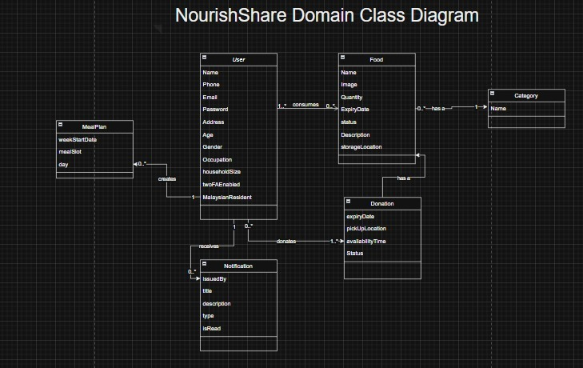
Figure 2: Domain Class Diagram of NourishShare Web Application
In the above figure, we have written all the required attributes and have shown the connection between each classes.

Entity Relationship Diagram
ERD is a diagram that is used in database design. It shows how data items are interrelated with each other in the system (Belcic & Stryker, n.d.). The entities for our web application are written below:
- User
- Food
- Category
- Donation
- Meal Plan
- Notification
The below diagram shows the relationship between the identified entities of our web application.
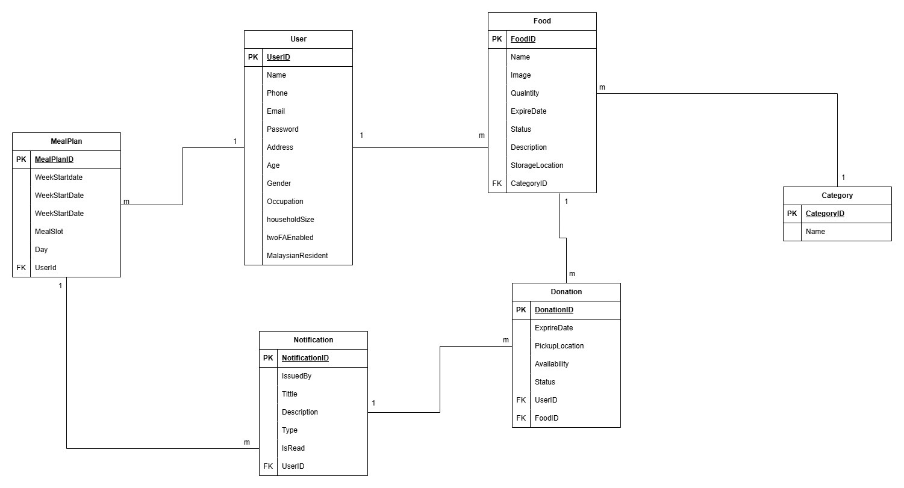
Figure 3: Entity Relationship Diagram of NourishShare Web Application

Site Map
The web application of NourishShare is made while considering the non-functional requirement like usability. So we have not included complex navigation structure. The users can easily understand how to visit different pages without any difficulties. The navigation hierarchy of the NourishShare is shown below in the diagram.
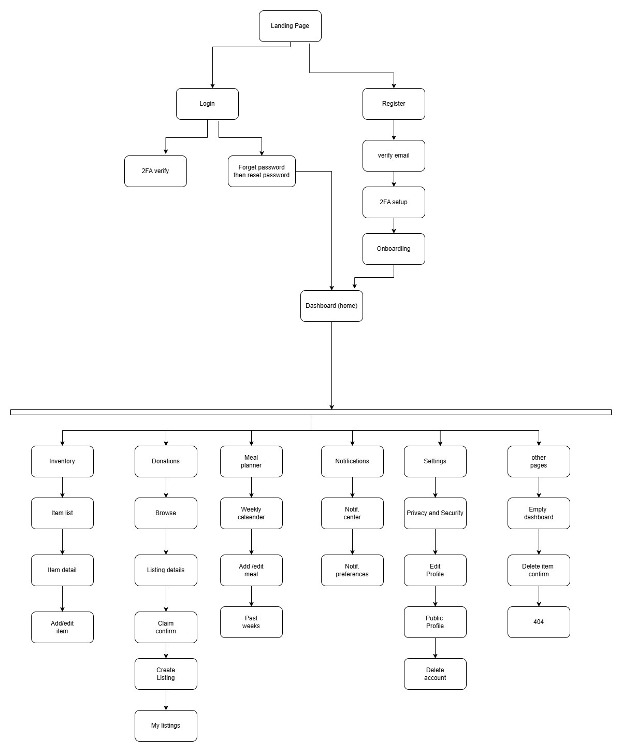
Figure 4: Site Map/ Hierarchy Diagram of Nourish Share Web Application

Wireframes and High Fidelity Images
A wireframe is a low level design which shows the simple layout of a web application or mobile application. It helps designers and developers to plan where the items are placed and how they can improve the user experience before making the final design (UX Design Institute, 2023). It can be made using Figma or using hand too.

Wireframes of NourishShare

Landing/ Home Page
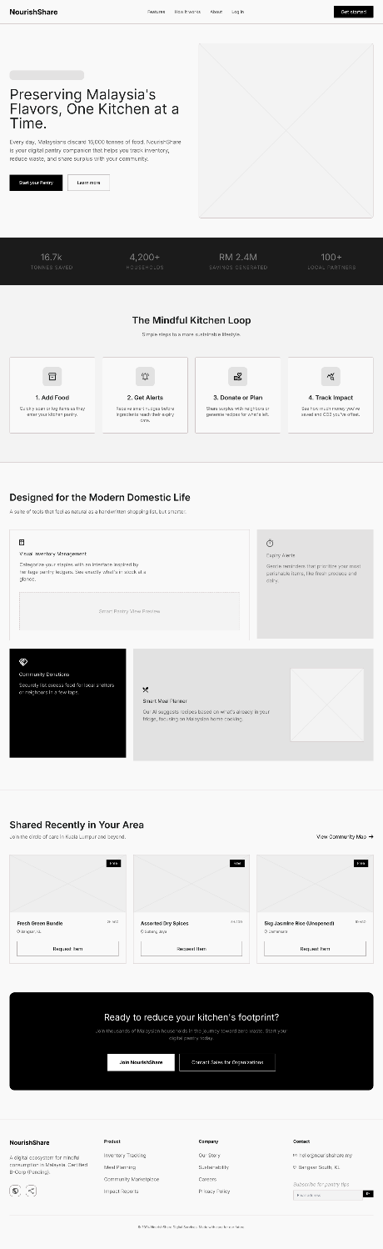
Figure 5: Landing Page Wireframe

Register Users Page
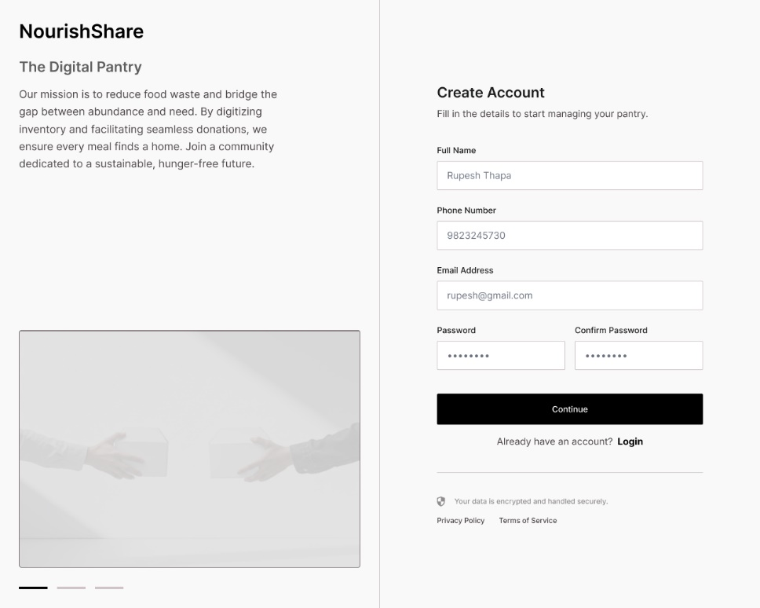
Figure 6: Register Page Wireframe

2FA Page
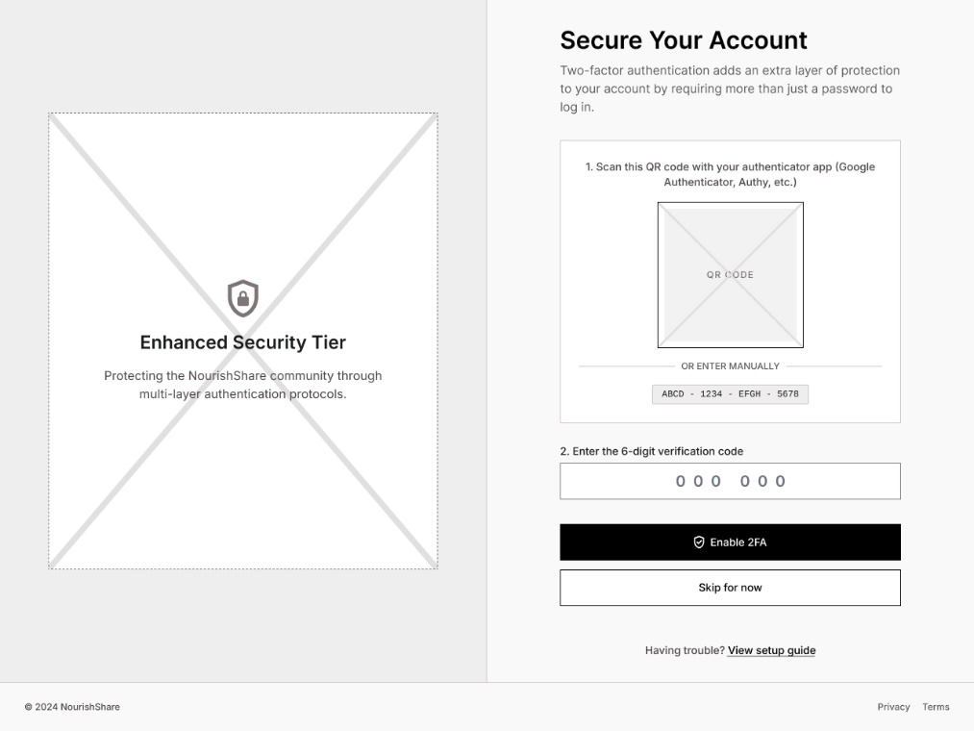
Figure 7: 2FA Wireframe

Account Privacy Page
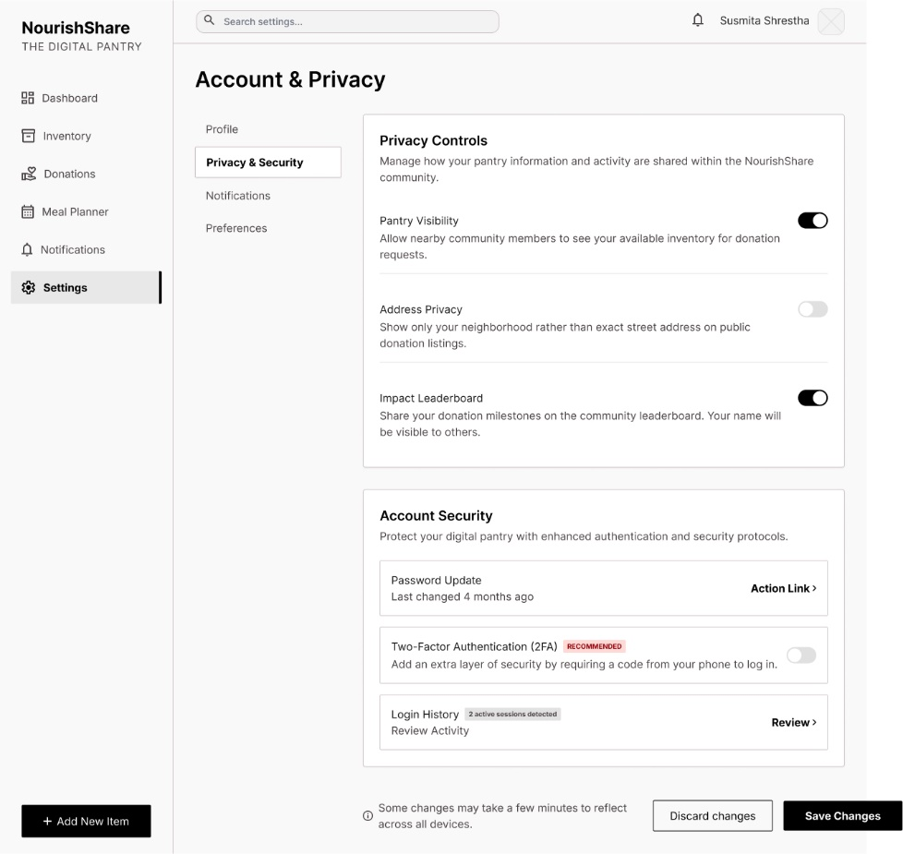
Figure 8: Account and Privacy Setting Wireframe

Login Page
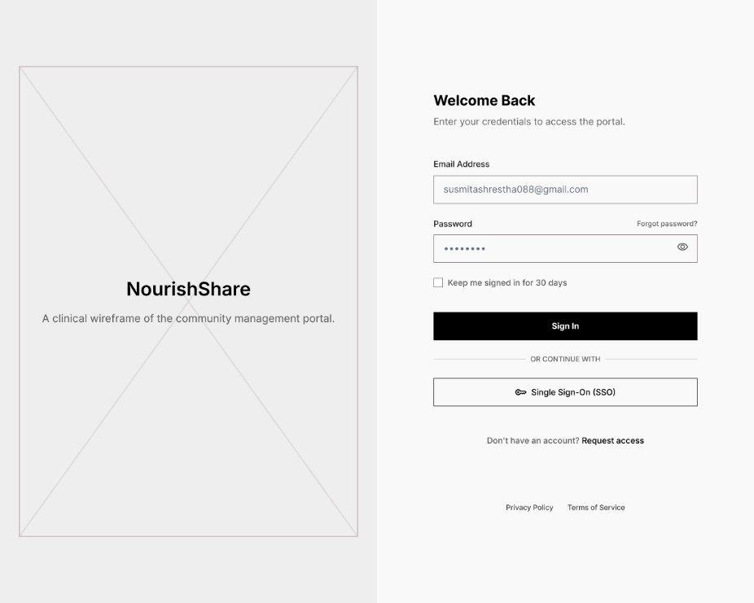
Figure 9: Login Page Wireframe

Food Inventory Page
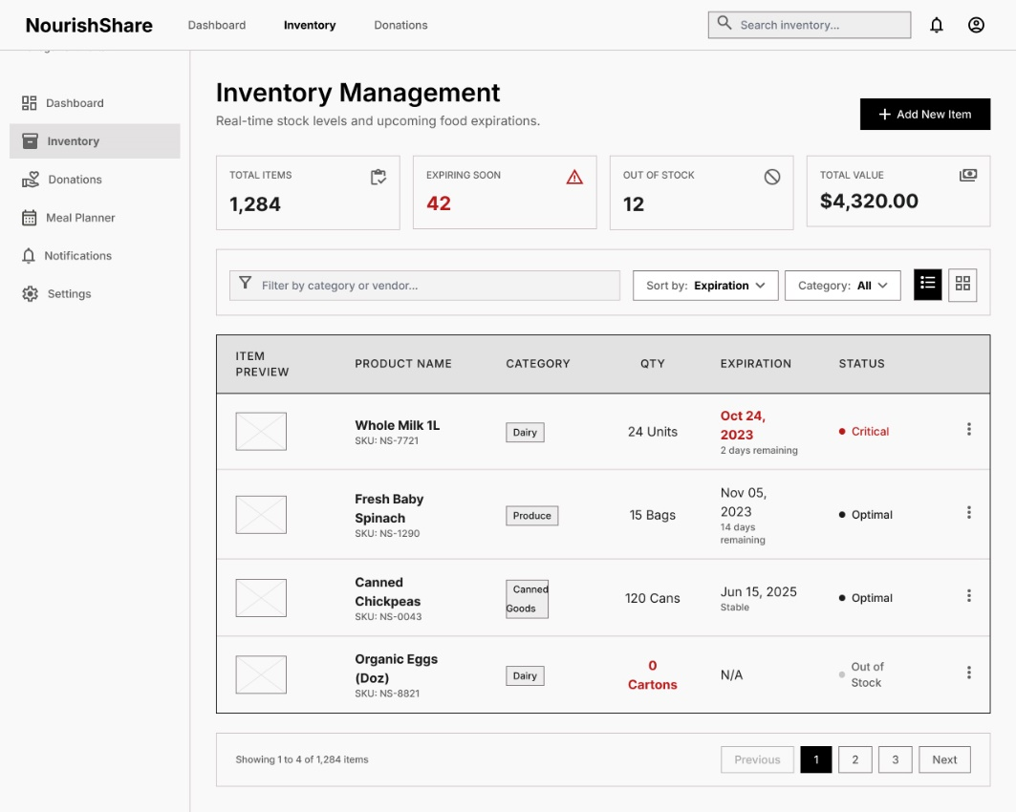
Figure 10: Inventory Management Wireframe

Food Item Details
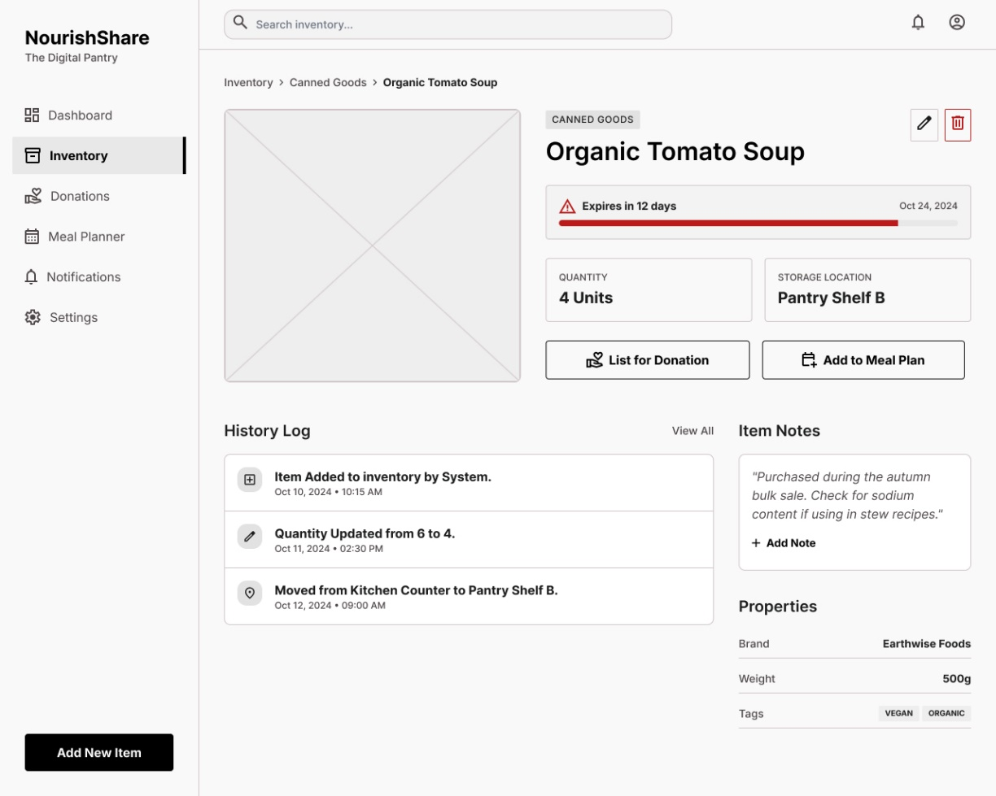
Figure 11: Food Item Details Wireframe

Add Item
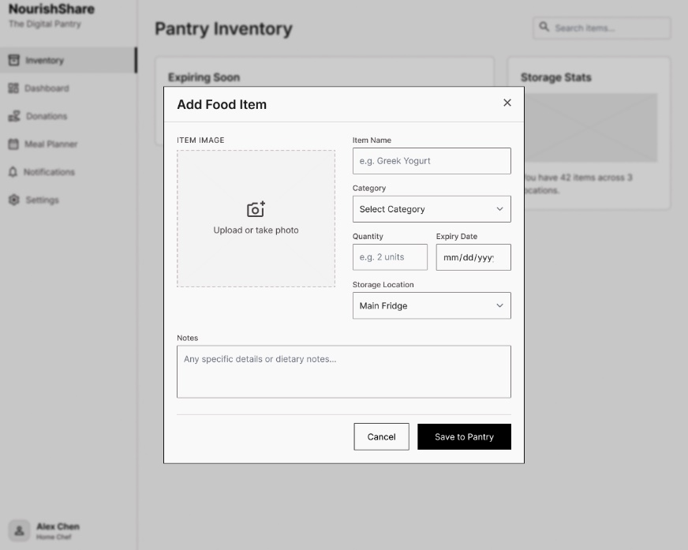
Figure 12: Add Food Items Wireframe

Delete Food Item Dialog Box
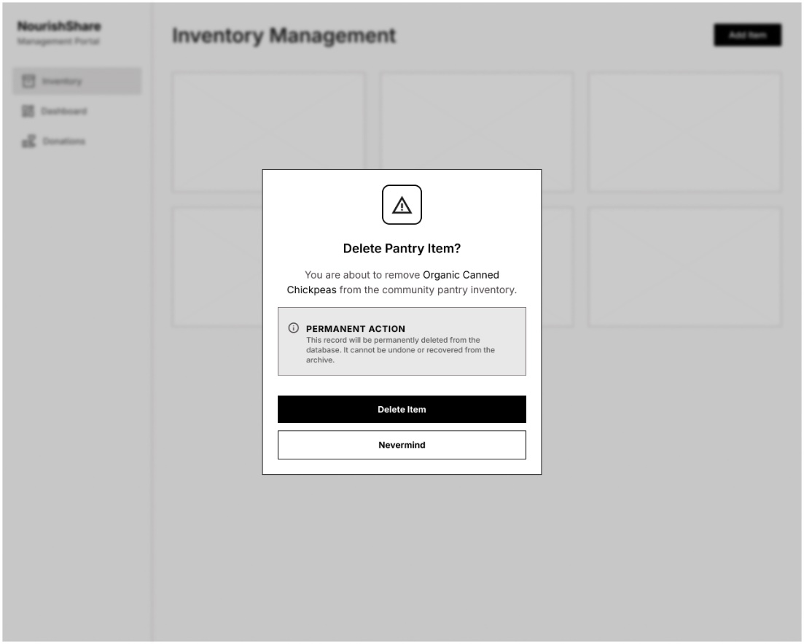
Figure 13: Delete Food Item Dialog Box Wireframe

Dashboard Page
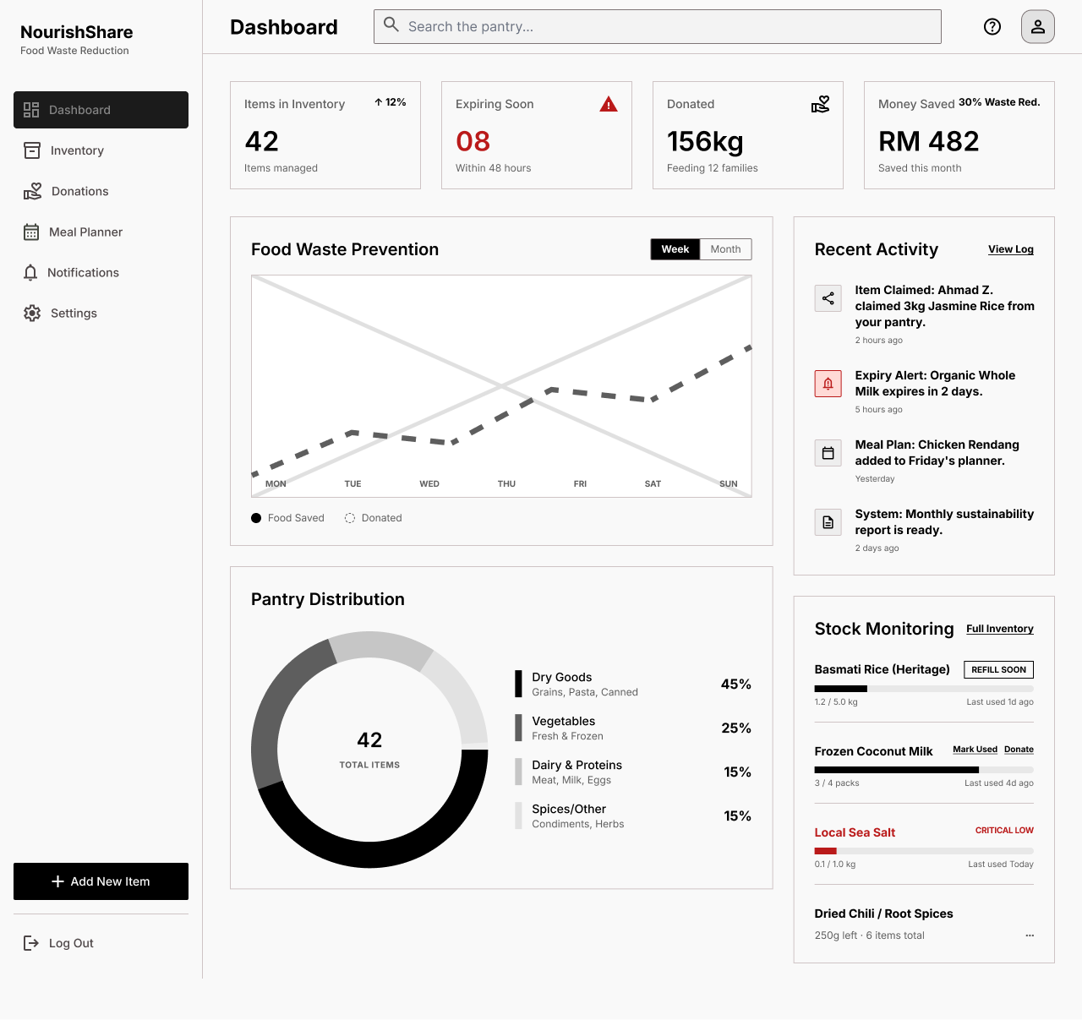
Figure 14: Dashboard Wireframe

Weekly Meal Plan
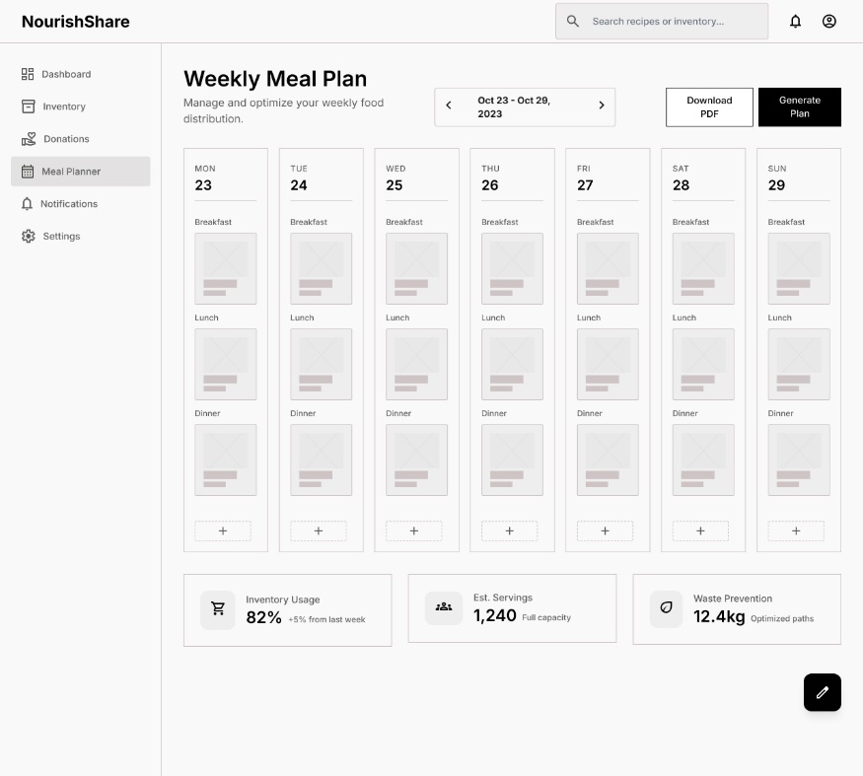
Figure 15: Weekly Meal Plan Wireframe

View Notifications Page
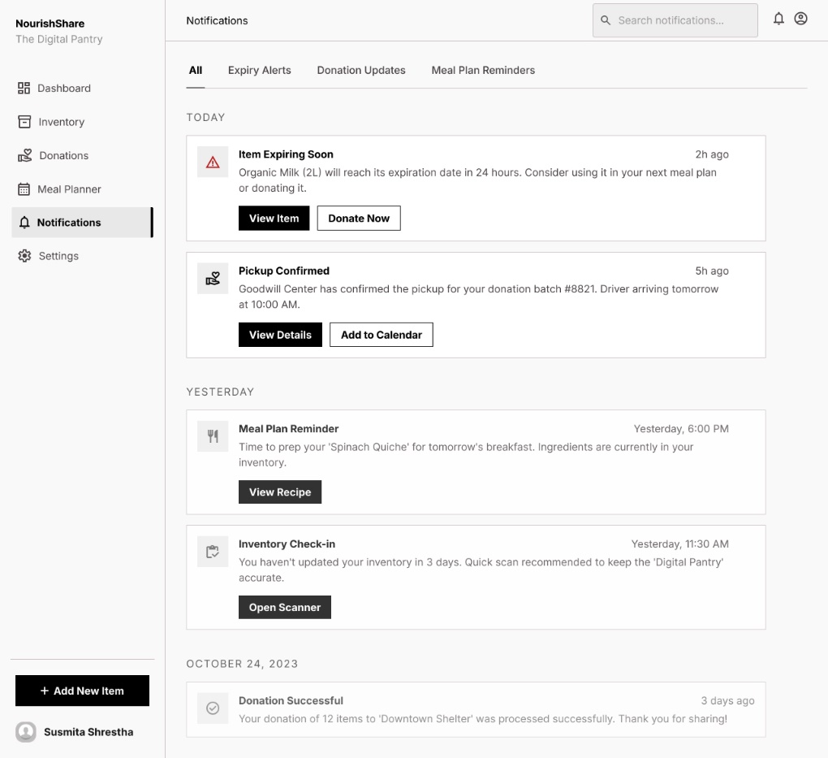
Figure 16: View Notifications Wireframe

High Fidelity Designs
The following images are the currently completed high fidelity designs of the NourishShare web application and it might differ from the initial wireframe outlines.

Landing Page
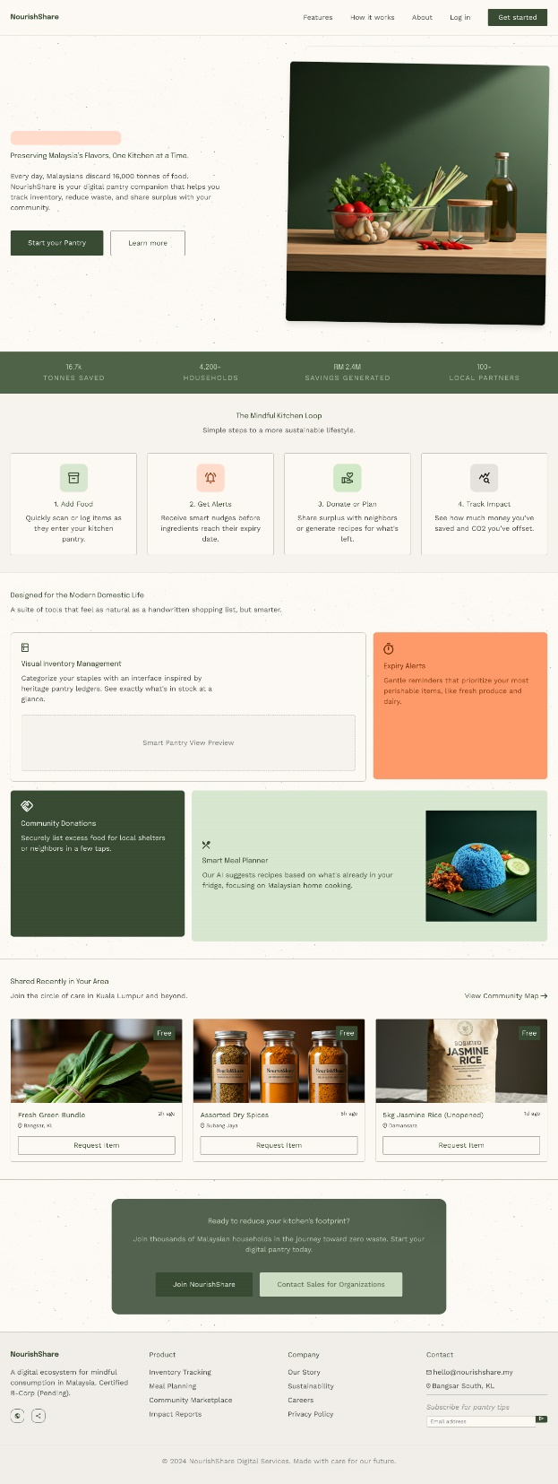
Figure 17: Landing Page Design

Register Page
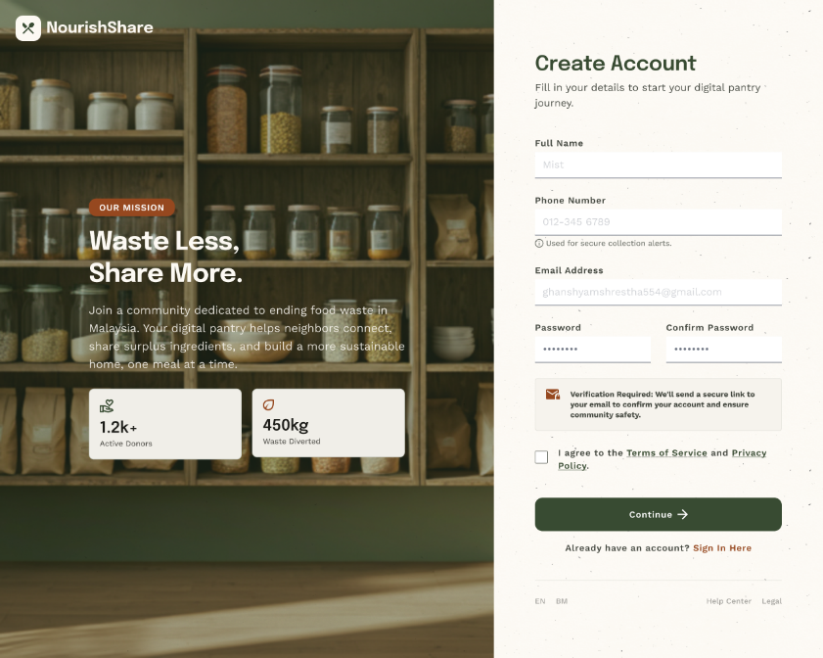
Figure 18: Register Page Design

View Notifications Page
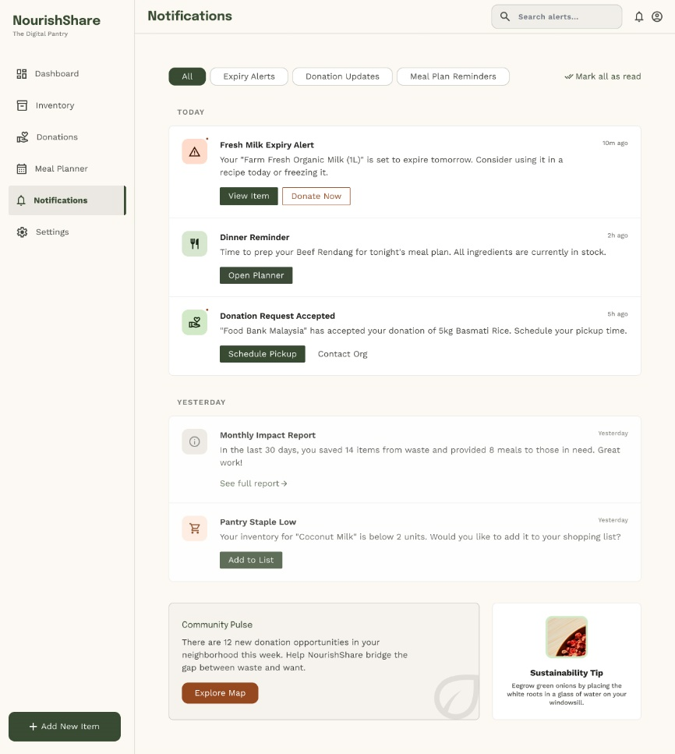
Figure 19: Notifications Page Design

Weekly Meal Plan Page
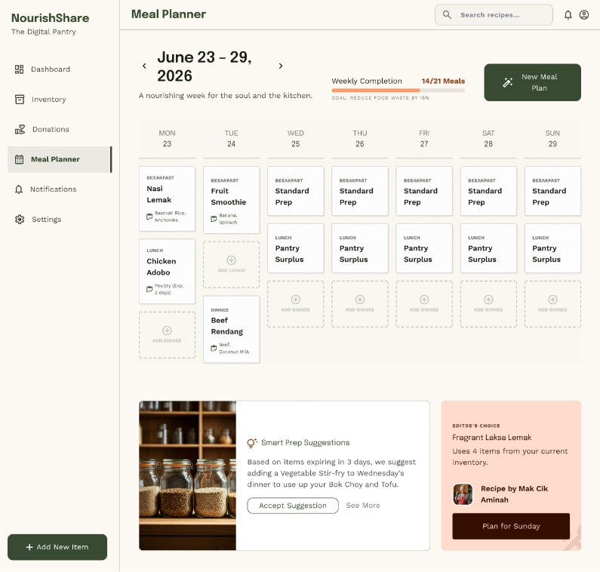
Figure 20: Weekly Meal Plan Design

Food Inventory Page
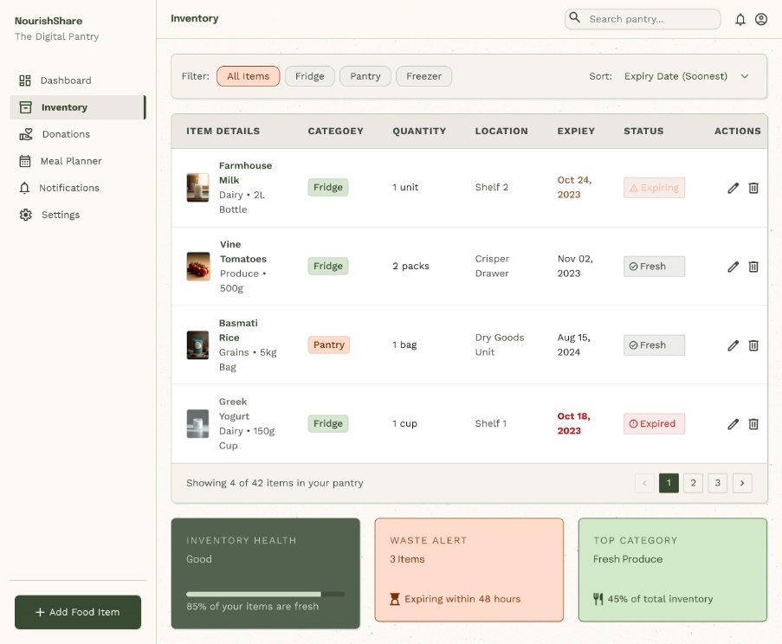
Figure 21: Food Inventory Page Design

Account and Privacy Settings Page
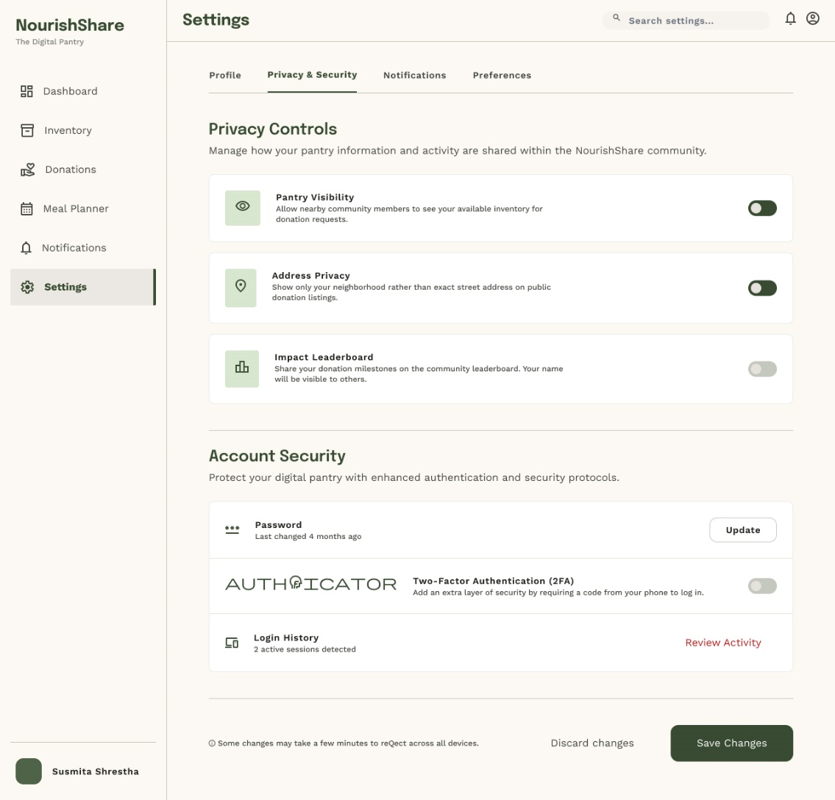
Figure 22: Account and Privacy Settings Design

System Design
The frontend part of web application will be built in React JS. This is because we can reuse the components again and again instead of writing the same code in different places of the codebase. Once the component is made it can be changed as per the requirement without writing extra code just by passing the props and the designs is sufficient for making it work and look different. The frontend communicates with backend with the help of API which is made using Express JS in the Backend. The API are made for inventory items, donations items, notifications, and meal planning.
The backend part will be done in Node JS and Express JS. They will be used for making the API endpoints for each module. For the authentication and authorization module, we will use JWT tokens and 2FA verification while logging in.
MongoDB is used as the database. This is to store the data of the six entities that we identified in the ERD and the Data Dictionary. To maintain the security of the application we used Bcrypt JS to hash the password so it is stored in the database in encrypted format instead of plain text.
We will try to deploy our web application using Docker if we do not face any time constraint.

Database Design
Database design is the process of planning and organizing data into entities, attributes, and relationships so that it can be stored, retrieved and maintained efficiently and consistently (McFarland, 2022). The below is the data dictionary of our web application:

Collection: Users
Field Name | Data Type | Description | Required | Validation
_id | ObjectId | Unique Identifier of user. | Yes | Auto generated
Name | String | Full name of the user. | Yes | Max 100 chars
Phone | String | Phone number of the user. | Yes | Unique
Email | String | Email address of the user. | Yes | Valid Email Format.
Password | String | Hashing password of the user. | Yes | Bcrypt JS Hashing.
Address | String | The address of the user. | Yes | Max 200 chars
Age | String | The age of user. | No | Min 13.
Gender | String | Gender of user. | Yes | Enum: Male, Female, Other.
Occupation | String | The occupation of the user. | No | Max 100 chars.
houseHoldSize | Number | The number of family member of the user. | Yes | Min 1
twoFAEnabled | Boolean | Whether the 2FA is enabled by the user or not. | Yes | Default: False
MalaysianResident | Boolean | Whether the user is a resident of Malaysia or not. | Yes | Default: Yes
Table 11: User collection table

Collection: Food
Field Name | Data Type | Description | Required | Validation
_id | ObjectId | Unique Identifier of food item. | Yes | Auto generated
Name | String | Full name of the food item. | Yes | Max 100 chars
Image | String | URL of the image converted using Cloudinary. | Yes | -
Quantity | Number | The quantity of food items. | Yes | Min 1
ExpiryDate | Date | The expiry date of the food item. | Yes | Expiry Date
Status | String | The current status of the item. | Yes | Enum: fresh, expiring, expired, donated.
Description | String | The detailed description or info about the food item. | No | Max 300 chars
storageLocation | String | Where the food item is stored. | No | -
userId | ObjectId | Reference to the User | Yes | Foreign Key - User
categoryId | ObjectId | Reference to the Category | Yes | Foreign Key - Category
Table 12: Food Collection Table

Collection: Category
Field Name | Data Type | Description | Required | Validation
_id | ObjectId | Unique Identifier of category. | Yes | Auto generated
Name | String | Name of the food category. | Yes | Max 50 chars
Table 13: Category Collection Table

Collection: Donation
Field Name | Data Type | Description | Required | Validation
_id | ObjectId | Unique Identifier of Donation. | Yes | Auto generated
expiryDate | Date | The expiry date of the donated item. | Yes | Future Date
pickUpLocation | String | The location where the item can be collected after claiming. | Yes | Max 200 chars
AvailabilityTime | String | The time when the item can be picked. | Yes
Status | String | The current status of the donation listing. | Yes | Enum: active, claimed, closed.
userId | ObjectId | Reference to the User | Yes | Foreign Key - User
foodId | ObjectId | Reference to the Food | Yes | Foreign Key - Food
Table 14: Donation Collection Table

Collection: MealPlan
Field Name | Data Type | Description | Required | Validation
_id | ObjectId | Unique Identifier of Donation. | Yes | Auto generated
weekStartDate | Date | Start date of the planned week. | Yes | Valid Date
mealSlot | String | Meal slot for the entry of food. | Yes | Enum: breakfast, lunch, dinner.
Day | String | Day of the week for the planned meal. | Yes | Enum: Mon-Sun
Status | String | The current status of the donation listing. | Yes | Enum: active, claimed, closed.
userId | ObjectId | Reference to the User | Yes | Foreign Key - User
Table 15: MealPlan Collection Table

Collection: Notification
Field Name | Data Type | Description | Required | Validation
_id | ObjectId | Unique Identifier of Donation. | Yes | Auto generated
issuedBy | String | The module that issues the notification. | Yes | -
Titile | String | The heading for the notification. | Yes | Max 100 char
Description | String | The notification message that is send to the users. | Yes | Max 250 chars
Type | String | The category of notification. | Yes | Enum: expiry, donation, meal.
isRead | Boolean | To check whether the notification issued is read by the user or not. | Yes | Default: false
userId | ObjectId | Reference to the User | Yes | Foreign Key - User
Table 16: Notification Collection Table

Future Recommendations
- In the future version, machine learning can be integrated so that we can accurately predict the expiry date based on the type of the food and the storage condition.
- A mobile app could be developed for the users to make it accessible directly in their smart devices.
- The system could be expanded by collaborating with different food banks and the NGOs to make the donation process more effective and easy.
- The platform could be made available in different languages so that people of different country can use it and also make their contribution in reducing the food wastage and donation.

Conclusion
This report presented the requirement specification and the design process of our web application. The functional and nonfunctional requirement of the web application were identified and written by categorizing them as per the MoSCoW. After identifying the functional and non-functional requirements we modelled them in user’s stories with acceptance criteria and MoSCoW prioritization for each team member. After that we developed the architectural diagram, domain class diagram, entity relationship diagram, and the site map to show how the flow of the web application is. We also developed the wireframes of the web application along with some high fidelity designs. We developed the diagrams in draw.io and the wireframes and the high fidelity designs in figma. Through this assignment we learned about the importance of requirement specification, how to design the system, develop wireframes and learned about the MoSCoW. This report provides a strong foundation for the development of the NourishShare in the upcoming assignment.

References
Belcic, I., & Stryker, C. (n.d.). What is an entity relationship diagram? IBM. https://www.ibm.com/think/topics/entity-relationship-diagram
GeeksforGeeks. (2025, July 23). What is domain class in UML? https://www.geeksforgeeks.org/system-design/what-is-domain-class-in-uml/
Guduru, S. (2025). Dynamic Component Rendering in React: Performance Challenges and Solutions. Journal of Computer Science and Technology Studies, 7(12), 27–37. https://doi.org/10.32996/jcsts.2025.7.12.5
IBM. (2023, September 21). Deployment diagrams in UML modeling. IBM Documentation. https://www.ibm.com/docs/en/rational-soft-arch/9.7.0?topic=diagrams-deployment
McFarland, R. (2022, August 26). Database and information systems development: Data dictionaries. Medium. https://highervista.medium.com/database-and-information-systems-development-data-dictionaries-5ecae154d861
UX Design Institute. (2023, November 13). What is wireframing? A complete guide. https://www.uxdesigninstitute.com/blog/what-is-wireframing/

Appendix

Appendix A – Deployment Diagram
https://drive.google.com/file/d/1GhTnznEli9dj4s_iemdpgRGBXSz4JBht/view?usp=sharing

Appendix B – Site Map
https://drive.google.com/file/d/1erUd6jFEAQIfCrSvW2IqxvO2zsf9w_FS/view?usp=sharing

Appendix C – Entity Relationship Diagram
https://drive.google.com/file/d/1I7v4rT7cCT_ALLkHTkkILGwkSAKxJSKS/view?usp=sharing

Appendix D – Figma Link
https://www.figma.com/design/B4GtUPpLTamvvK3f5CkT2u/NoruishShare?node-id=0-1&t=zyJuO9KJEcDBQ3yQ-1

